Education & Skills  People  Cumbria House  107-117 Botchergate  Carlisle
Cumbria  CA1 1RD 
T: 01228 226884  E: daniel.barton@cumbria.gov.uk

21st April 2020

Dear Colleague

Following advice from Ofqual, schools have been asked not to provide predicted grades for students at GCSE or A level for this year. We understand this may pose problems for FE, HE and independent providers in determining how to offer places on courses at all levels.

We have advised schools that they should provide comprehensive references and recommendations to make sure students are accepted onto the appropriate courses for them in September without providing predicted grades.

We would ask all FE and HE providers, and employers, to work with us in making sure that students moving on from schools and colleges into FE and employment are supported and not disadvantaged by schools being unable to provide predicted grades at the moment.

If you have any questions or concerns, please do not hesitate to contact me.

Yours sincerely

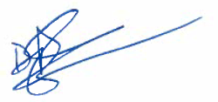
Dan Barton
Assistant Director – Education & Skills

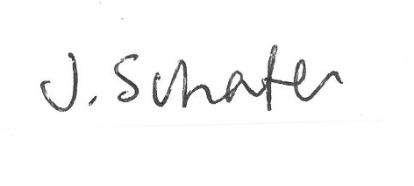
Judith Schafer
Executive Headteacher
Solway and Beacon Hill Community Schools

