Health and Safety Management Guidance for Head teachers in schools providing education to key workers children

Introduction
Firstly, we would like to reassure Head teachers that the Local Authority will provide access to advice and guidance direct to all hub settings throughout the current situation. You will find contact details for relevant teams at the end of this guidance note.
All settings will need to continue to take precautions to limit the spread of the virus and infection prevention control guidance has already been shared with Schools by our Public Health Team and is accessible here https://content.govdelivery.com/accounts/UKCCC/bulletins/282a40b This covers specific guidance for staff and advice on what to do if someone becomes ill.
We will not cover all safety management risk control requirements in this document. So Head teachers and relevant staff are urged to contact the Health and Safety team with any specific queries.

Risk Assessment
Accompanying this guidance note we have provided a model COVID-19 risk assessment which can be tailored for each setting. Check through the recommended control measures to ensure they are applicable. Should you require any direct support, advice or guidance please contact the Health and Safety Team.

Emergencies
Schools should already have well developed procedures in place to address foreseeable accidents and emergency situations e.g. First Aid, Fire (PEEPS) etc. The key thing to ensure is that these remain in place, are appropriate to current circumstances and that they are understood by all staff working in the setting.

Medical Issues
Current National Guidance to Schools from Public Health England does not advocate the need for staff to take the temperatures of those attending the setting – Public Health advice is clear that those who are symptomatic MUST self-isolate for 7 days if living alone or 14 days if living with others (this includes all household members) following staying at home guidance.

Symptomatic means those who develop either:
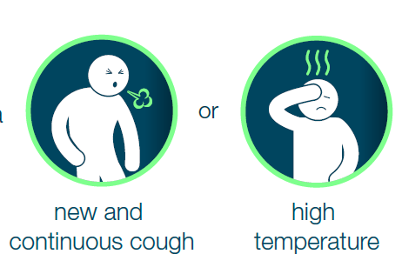
Should anyone develop symptoms whilst in the setting then the Infection Prevention and Control Guidance from Public Health see link above should be followed.

Cleaning, Hygiene and Waste Management
It is important to ensure that effective cleaning, hygiene and waste management arrangements are in place and maintained. This should cover cleaning and disinfection of regularly touched objects and surfaces. Cleaning of these high contact points should be done more often than usual with standard cleaning products. National Guidance on cleaning in non-clinical settings is hosted here
Posters and advice should be displayed to staff, pupils and parents
National Guidance Stop the Spread Poster
National Guidance Cleaning in Non-Healthcare Settings Poster

Building Maintenance Issues
There is always the need to ensure that each school building and equipment remain safe. However, in the current situation Public Health remains the priority.
Restrictions on access to buildings in line with delaying the spread of infection will need to be made.
Access should only be granted by arrangement for essential maintenance/ statutory inspection needs only – even then the requirements for some statutory inspections due to take place over the coming months may well be relaxed, as the Government have done with MOTs. The County Council are monitoring and awaiting further guidance and are working with key contractors to determine a best practice approach to managing this. Further communications will be shared as relevant. Please contact the Health and Safety Team for specific advice where required.
In an emergency situation – where access is required urgently to undertake maintenance - appropriate hygiene and social distancing arrangements must be followed.

Contacts
Health and Safety Team
The County Council’s Health and Safety Team will provide ongoing H&S support through our usual function.

For support and guidance please contact:
Email: healthandsafety@cumbria.gov.uk Office Hours No 01228 221616
Or direct through Health and Safety Advisors mobile numbers

Judith Chandler, Lead Health Safety and Wellbeing Advisor – Schools/ Children’s - Judith.Chandler1@cumbria.gov.uk 07584 534670

Judy Hutchinson, Assistant Health Safety and Wellbeing Advisor -
Judy.Hutchinson@cumbria.gov.uk 07825 340473

Sharon McCubbin, Senior Health Safety Wellbeing Manager – Sharon.mccubbin@cumbria.gov.uk 07825 340570

We continue to man our out of hours number for Health and Safety emergencies - 0300 303 1042. Please call and leave a message and an Advisor will contact you as soon as possible

Public Health
Public Health have a dedicated helpline number for educational settings – please call 0800 046 8687 for any specific question not covered within their guidance.

