EXCELLENT OPPORTUNITY TO ATTEND A FULLY FUNDED TRAINING COURSE
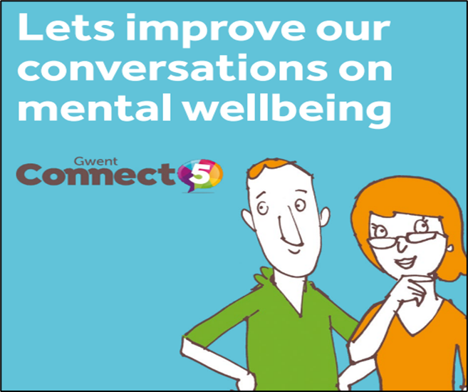

The Gwent Connect 5 Programme includes two fully funded training courses:
- Gwent Connect 5 – targeted at workforces working with adults
- Young People Connect 5 – targeted at workforces working with 16–25-year-olds
If you want to improve your knowledge, confidence and skills to have effective mental health conversations then these are the courses for you. Each course is made up of three half day modules which can be completed at your leisure. Each module builds your knowledge, skills and confidence.
What participants have said about the course:
“It gives you a toolkit you can use (unlike other training)”
“The delivery was so engaging, enthusiastic and passionate”
“Now we have tools we can work with!”
To find out more about these courses visit: Gwent Connect 5 Training Programme | Melo Cymru or contact Victoria on victoriaenglishwellbeing@gmail.com.
To book your free place visit: https://gc5.melo.cymru/available-sessions/6154218a7a3dc400164143f8
Adults
22nd June Thursday 9.30-12.30 module 1
https://gc5.melo.cymru/register/DJdeq8IIe
27th June Tuesday 9.00 am Module 1
https://gc5.melo.cymru/register/Ysbu-y9Io
28th June Wednesday 9.00 -4.30 module 2 & 3
https://gc5.melo.cymru/register/tJtCpU3au
10th July Monday 9.00 -12.30 Module 1
https://gc5.melo.cymru/register/9ok5fvIB_
10th July Monday 1.00 -16.30 Module 2
https://gc5.melo.cymru/register/FO81RflXx
11th July Tuesday 9.00-12.30 Module 1
https://gc5.melo.cymru/register/YQ0jne-Q1
12th July Wednesday 9.00-12.30 module 2
https://gc5.melo.cymru/register/6WgXEzrxP
12th July Wednesday 1.00 -4.30
https://gc5.melo.cymru/register/s0Qsd_Mqo

Young People
20th July Thursday 9.00 - 4.30 Module 1 &2
https://gc5.melo.cymru/register/Egk-UPOMC
24th July Monday 9.30 - 1.00 Module 1
https://gc5.melo.cymru/register/hIpaaSm_J
24th July Monday 1.00 - 16.30 Module 2
https://gc5.melo.cymru/register/e_hExhoEp
28th July Friday 9.00 - 12.30 Module 3
https://gc5.melo.cymru/register/P17rHr0JX

Updated by Gwent Connect 5 Trainer: Victoria English, June 2023

