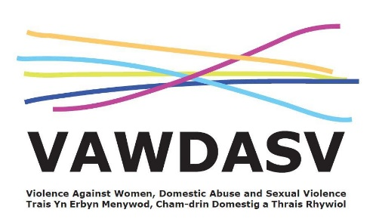

National Training Framework - Group 3 - Ask and Act - Champions
A full day session; increase understanding of VAWDASV in the context of the whole family and increasing confidence and knowledge in supporting staff who Ask and Act. Enabling effective championing of VAWDASV
Facilitated by: Gwent Training Consortia Delivery: on MS Teams
Aims and Objectives:
- Be able to consider violence against women, domestic abuse and sexual violence in the context of a whole family
- Have an ability to assess risk in appropriate cases of violence against women, domestic abuse and sexual violence
- Demonstrate an ability to support colleagues in relation to violence against women, domestic abuse and sexual violence.
Prerequisites:
- Must work for an organisation in Gwent
- Priority will be set for staff working for; Blaenau Gwent County Borough Council, Caerphilly County Borough Council, Monmouthshire County Council, Newport City Council, Torfaen County Council or Aneurin Bevan University Health Board.
- Must have completed National Training Framework Group 1 and Group 2 Ask and Act Awareness
Target group:
- Those with a lead responsibility for their profession in terms of VAWDASV
- Those who are working with a client group experiencing high prevalence of VAWDASV
- Those required or wanting to fulfil a “champion” role within their team or organisation.
Booking:
- All dates are scheduled and places open for booking 5 weeks prior to training.
- You can save a date in the future to your diary and then click the “Remind me” button so you will get a reminder when places are open for booking.

Booking Links

Monday 5th June 2023 – Full Day Session

Group 3 - https://www.eventbrite.co.uk/e/ask-and-act-group-3-training-tickets-589394092597

Thursday 28th September 2023 – Full Day Session

Group 3 - https://www.eventbrite.co.uk/e/ask-and-act-group-3-training-tickets-589404002237

Thursday 14th December 2023 – Full Day Session

Group 3 - https://www.eventbrite.co.uk/e/ask-and-act-group-3-training-tickets-589411976087

Wednesday 27th March 2024 – Full Day Session

Group 3 - https://www.eventbrite.co.uk/e/ask-and-act-group-3-training-tickets-589421163567

Or scan this code for all Ask and Act dates


