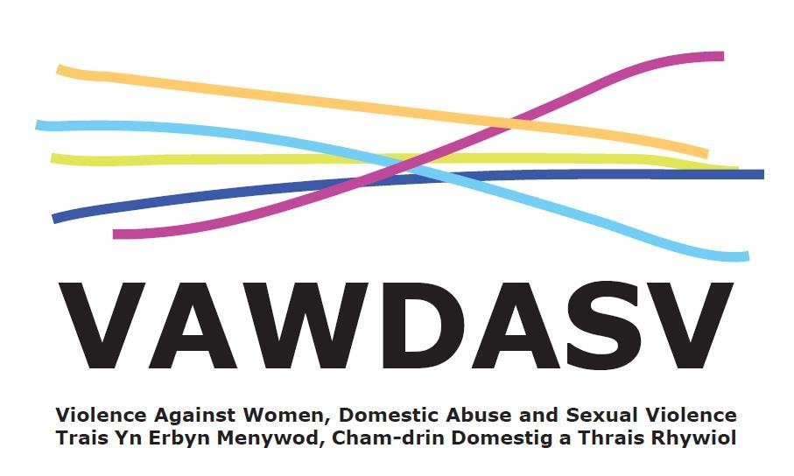
National Training Framework - Group 2 - Ask and Act
Multi Agency Sessions
A half day course to; increase confidence and understanding of early identification, making a targeted enquiry and knowing referral pathways.
Facilitated by: Hafan Cymru / Llamau / Gwent Training Consortia Delivery: on MS Teams
Aims and Objectives:
- Recognise the signs and symptoms of violence against women, domestic abuse and sexual violence.
- Understand the purpose of and demonstrate an ability to undertake targeted enquiry
- Demonstrate knowledge around data protection and the duty of confidentiality.
- Understand the purpose of risk identification in relation to some forms of violence against women, domestic abuse and sexual violence
- Be able to implement the targeted enquiry care pathway
Prerequisites:
- Must work for an organisation in Gwent
- Must work in the Education Sector
- Priority will be set for staff working for; Blaenau Gwent County Borough Council, Caerphilly County Borough Council, Monmouthshire County Council, Newport City Council, Torfaen County Council or Aneurin Bevan University Health Board.
- Must have completed National Training Framework Group 1 and Group 2 Ask and Act Awareness
Target group:
- Those in a public facing role in which either an assessment is made and/or care is delivered, and which provides an opportunity to “ask” (this may be one off contact or as part of on-going support)
- Those with internal responsibility role such as HR, Managers, and Personnel leads.
- Those in a role where their client group is likely to have experienced a form of VAWDASV
- Those in a setting or location which is reason alone to “Ask and Act” (midwifery, mental health, child protection)
Booking:
- All dates are scheduled and places open for booking 8 weeks prior to training.
- You can save a date in the future to your diary and then click the “Remind me” button so you will get a reminder when places are open for booking.

Booking Links
May 2023
10th May 2023 AM – Group 2 – Multi-agency - https://www.eventbrite.co.uk/e/ask-and-act-group-2-training-am-tickets-596775239807

10th May 2023 PM – Group 2 – Multi-agency - https://www.eventbrite.co.uk/e/ask-and-act-group-2-training-pm-tickets-596775540707

July 2023

5th July AM - Group 2 – Multi-agency - https://www.eventbrite.co.uk/e/ask-and-act-group-2-training-am-tickets-589357673667

5th July PM – Group 2 – Multi-agency - https://www.eventbrite.co.uk/e/ask-and-act-group-2-training-pm-tickets-589379739667

September 2023

13th September AM – Group 2 – Multi-agency - https://www.eventbrite.co.uk/e/ask-and-act-group-2-training-am-tickets-596778780397

13th September PM – Group 2 – Multi-agency - https://www.eventbrite.co.uk/e/ask-and-act-group-2-training-pm-tickets-596780746277

October 2023

11th October AM – Group 2 – Multi-agency - https://www.eventbrite.co.uk/e/ask-and-act-group-2-training-am-tickets-597640216977

11th October PM – Group 2 – Multi-agency - https://www.eventbrite.co.uk/e/ask-and-act-group-2-training-pm-tickets-597643476727

November 2023

15th November AM – Group 2 – Multiagency - https://www.eventbrite.co.uk/e/ask-and-act-group-2-training-am-tickets-589382126807

15th November PM – Group 2 – Multiagency - https://www.eventbrite.co.uk/e/ask-and-act-group-2-training-pm-tickets-589382347467

December 2023

5th December AM – Group 2 – Multiagency - https://www.eventbrite.co.uk/e/ask-and-act-group-2-training-am-tickets-589387171897

5th December PM – Group 2 – Multiagency - https://www.eventbrite.co.uk/e/ask-and-act-group-2-training-pm-tickets-589386339407

January 2024

18th January AM – Group 2 – Multiagency - https://www.eventbrite.co.uk/e/ask-and-act-group-2-training-am-tickets-597823274507

18th January PM – Group 2 – Multiagency - https://www.eventbrite.co.uk/e/ask-and-act-group-2-training-am-tickets-598268556357

February 2024

7th February AM – Group 2 – Multiagency - https://www.eventbrite.co.uk/e/ask-and-act-group-2-training-am-tickets-598304213007

7th February PM – Group 2 – Multiagency - https://www.eventbrite.co.uk/e/ask-and-act-group-2-training-pm-tickets-598307011377

March 2024

13th March AM – Group 2 – Multiagency - https://www.eventbrite.co.uk/e/ask-and-act-group-2-training-am-tickets-598312808717

13th March PM – Group 2 – Multiagency - https://www.eventbrite.co.uk/e/ask-and-act-group-2-training-pm-tickets-598316429547

Or scan this code for all Ask and Act dates


