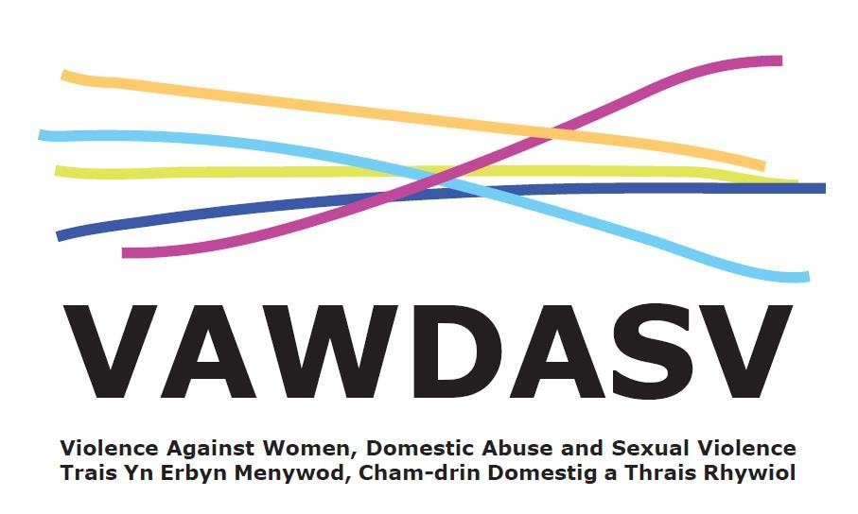
National Training Framework - Group 2 - Ask and Act
Sessions for Education Staff
A half day course to; increase confidence and understanding of early identification, making a targeted enquiry and knowing referral pathways.
Facilitated by: Hafan Cymru / Llamau / Gwent Training Consortia Delivery: on MS Teams
Aims and Objectives:
- Recognise the signs and symptoms of violence against women, domestic abuse and sexual violence.
- Understand the purpose of and demonstrate an ability to undertake targeted enquiry
- Demonstrate knowledge around data protection and the duty of confidentiality.
- Understand the purpose of risk identification in relation to some forms of violence against women, domestic abuse and sexual violence
- Be able to implement the targeted enquiry care pathway
Prerequisites:
- Must work for an organisation in Gwent
- Must work in the Education Sector
- Priority will be set for staff working for; Blaenau Gwent County Borough Council, Caerphilly County Borough Council, Monmouthshire County Council, Newport City Council, Torfaen County Council or Aneurin Bevan University Health Board.
- Must have completed National Training Framework Group 1 and Group 2 Ask and Act Awareness
Target group:
- Those in a public facing role in which either an assessment is made and/or care is delivered, and which provides an opportunity to “ask” (this may be one off contact or as part of on-going support)
- Those with internal responsibility role such as HR, Managers, and Personnel leads.
- Those in Key Safeguarding Roles – DSP, Leads and Teaching Staff
- Those in a role where their client group is likely to have experienced a form of VAWDASV
- Those in a setting or location which is reason alone to “Ask and Act” (midwifery, mental health, child protection)
Booking:
- All dates are scheduled and places open for booking 8 weeks prior to training.
- You can save a date in the future to your diary and then click the “Remind me” button so you will get a reminder when places are open for booking.

Booking Links
Thursday 27th April 2023

AM Session – Group 2 – Education - https://www.eventbrite.co.uk/e/ask-and-act-group-2-training-education-am-tickets-579250843867

PM Session – Group 2 – Education - https://www.eventbrite.co.uk/e/ask-and-act-group-2-training-education-am-tickets-579250843867

Thursday 22nd June 2023

AM Session – Group 2 – Education - https://www.eventbrite.co.uk/e/ask-and-act-group-2-training-education-am-tickets-596776323047

PM Session – Group 2 – Education - https://www.eventbrite.com/e/596776995057

Tuesday 10th October 2023

AM Session – Group 2 – Education - https://www.eventbrite.co.uk/e/ask-and-act-group-2-training-education-am-tickets-589381384587

PM Session – Group 2 – Education - https://www.eventbrite.co.uk/e/ask-and-act-group-2-training-education-pm-tickets-589381896117

Wednesday 28th February 2024

AM Session – Group 2 – Education - https://www.eventbrite.co.uk/e/ask-and-act-group-2-training-education-am-tickets-589390772667

PM Session – Group 2 – Education - https://www.eventbrite.co.uk/e/ask-and-act-group-2-training-education-pm-tickets-589392307257

Or scan this code for all Ask and Act dates


