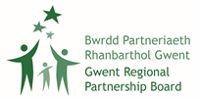

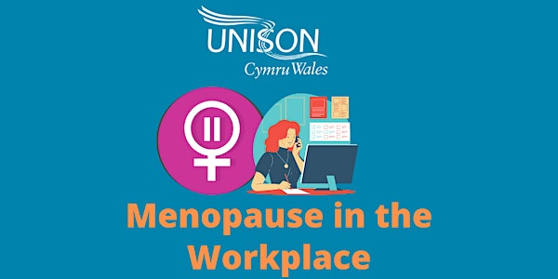

Menopause in the Workplace
Gwent, Online Webinars
Delivered by Unison

Hello,
The Gwent Regional Partnership Board has partnered with Unison to facilitate two introductory Menopause in the Workplace webinars. These webinars will provide social care workers and managers in Gwent with an awareness of the menopause and explore why the menopause is a workplace issue.
Menopause can affect all areas of life, and work is no exception. We are inviting you to join Jenny Griffin from UNISON’s Wales Union Learning Fund to find out more about the menopause in the workplace.
These online sessions will look at:
- Definitions of the menopause
- Identifying symptoms of the menopause
- Employment legislation relating to menopause
- Why the menopause is a workplace issue
- How to support menopause at work
Dates and Times of the Webinars
These webinars will be delivered online via Teams. Delegates will need access to a computer and a working internet connection to attend and take part.
Please note the same programme will be delivered at both webinars so delegates only need to book onto one webinar.
- Thursday the 11th of May, 10:00am to 11:30
- Thursday the 18th of May, 10:00am to 11:30
How to Book onto the Webinars
The number of spaces available for each webinar is capped at 16 and these will be allocated on a first come first served basis.
If demand is high, we will be happy to explore organising additional webinars in the future.
If you would like to book a place on one of the webinars, then please e-mail Ellys Perry: Ellys.Perry@torfaen.gov.uk
In your E-mail please state:
- Your name
- Organisation
- Date of the webinar you would like to attend

END

