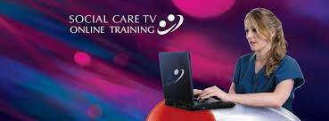

Accredited e-learning provider

Social Care TV is an accredited and endorsed training provider. We take great pride in the standard of the products we offer. As a result, we have been awarded accreditation by Continuing Professional Development (CPD) UK and are fully endorsed by Skills for Care.

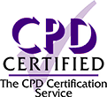 

Online health and social care courses are available in the following areas

Care Certificate, Health and safety, Hygiene, Mental health, Physical health, Planning and management

If you would like access to this free eLearning please contact [WDblaenaugwent@caerphilly.gov.uk](mailto:WDblaenaugwent@caerphilly.gov.uk)