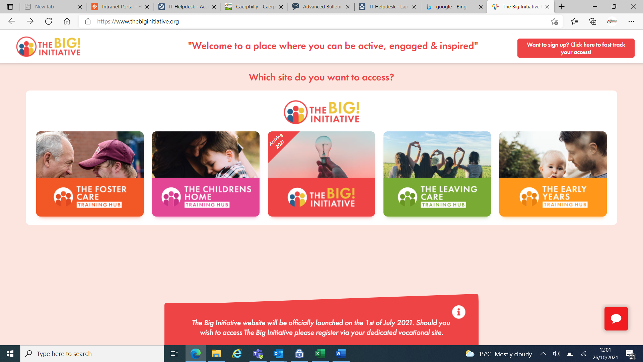

**The Social Care Training Hub is the UK’s largest hub of resources, created specifically for the Social Services Sector. Covering Foster Carers, Children’s Homes and Children’s Services**

**They offer over 600 fun, engaging, and interactive eLearning options, which is supported by exceptional CPD accredited and Wales compliant online training – covering all standards and regulations.**

**For access, please email** [**WDblaeanugwent@caerphilly.gov.uk**](mailto:WDblaeanugwent@caerphilly.gov.uk)

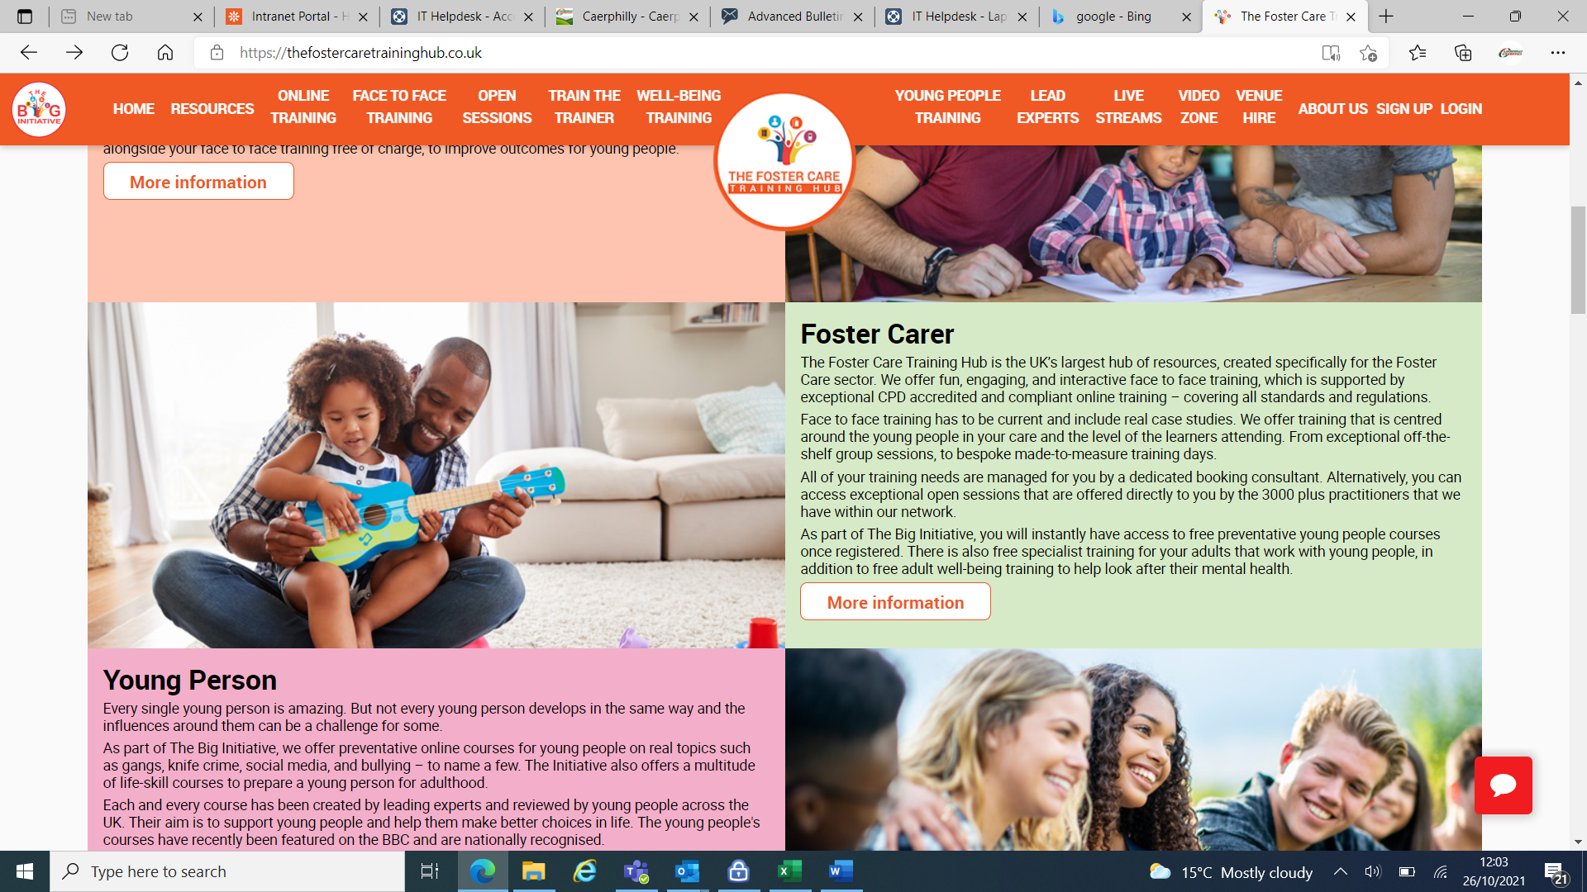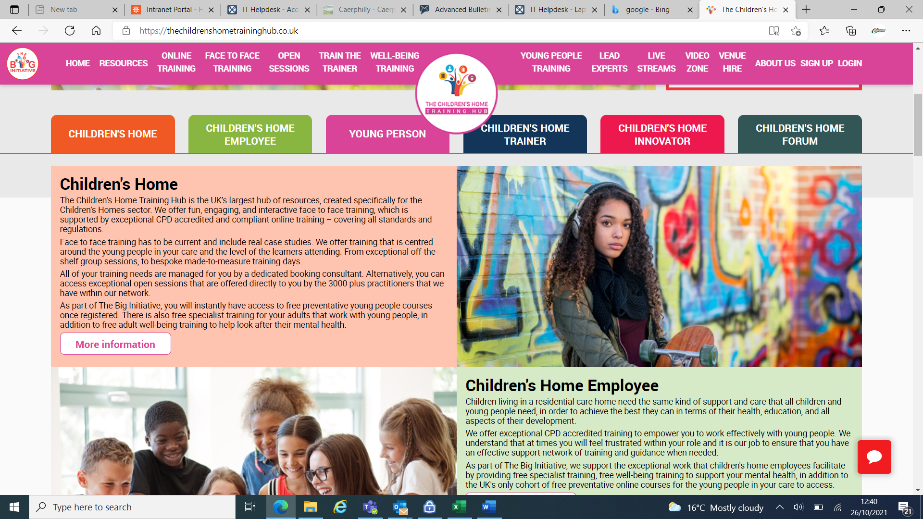

**Foster Carer**

The Foster Care Training Hub is the UK’s largest hub of resources, created specifically for the Foster Care sector. They offer fun, engaging, and interactive eLearning options, which is supported by exceptional CPD accredited and Wales compliant online training – covering all standards and regulations.

**Children’s Homes**

The Children’s Home Training Hub is created Specifically for the Children’s Home sector and is the UK’s largest Hub of resources. They offer fun, engaging and interactive learning options, which is supported by exceptional CPD accredited and Wales compliant online training – covering all standards and regulations.



**Children’s Services**

The Children’s Services Training Hub is the UK’s largest hub of resources, created specifically for everyone working in Children’s Services. They offer fun, engaging, and interactive eLearning options, which is supported by exceptional CPD accredited and Wales compliant online training – covering all standards and regulations.