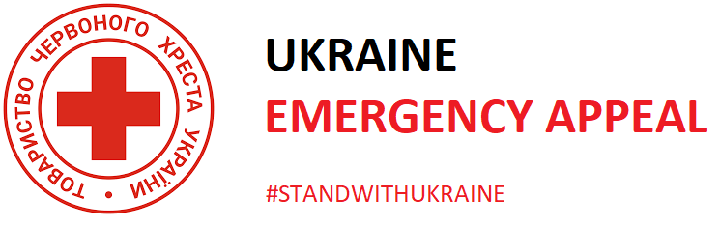

The Boat and Horses
Trent Rd, Beeston Rylands NG9 1LP
0115 9677799
Friday 25th March

Please bring a Donation for
The Boat & Horses Ukraine Emergency Appeal
please come to the Comedy Night from 7pm on 25th March
All profits from ticket Sales to be donated to Ukraine Red Cross
Calpol sachets | Battery Torch | Sanitary Products
Multivitamins | Wind Up Torch | Adult Socks
Plasters | Batteries | Childrens Socks
Paracetamol | Silver Foil Blanket | Wet Wipes
Aspirin | Hand Gel | Dried Milk
E24 cream | Soap | Dried Pasta
Toothpaste | Toilet Roll | Rice
Toothbrushes | Tinned Food | Tinned Food all sorts
Shampoo | Tinned Pet Food | Spectacles
Antiseptic Cream | Pet Vitamins | Sleeping bags

