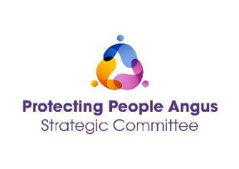
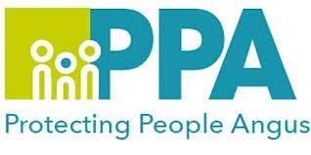
Domestic Abuse (Coercive Control) and the Law
Learning outcomes
- To introduce and gain an understand of the Domestic Abuse (Scotland) 2018 Act, and its implementation into practice.
- Exploration of the Police Scotland disclosure system.
- Gain an understand of the barriers to reporting using domestic abuse legislation.
- To understand how civil and criminal legislation on domestic abuse interacts and where the gaps are.
- To highlight the role of the services and how this may impact on practice.
- Domestic Homicide and Suicide reviews.
Facilitator
This session is being facilitated by Marianne Osborne who has worked with Renfrewshire Women’s Aid since 2002, and who has a wealth of experience and knowledge around the area of Domestic Abuse both at a local and national level.
Audience
This training is open to all multiagency staff that work in Angus and Tayside, who have a working understanding of Domestic Abuse.
DATE | TIME | LOCATION
24th March 2026 | 10:00 -12:00 | MS Teams
1st September 2026 | 10:00 - 12:00 | MS Teams

Please save the date in your calendar as the link will be sent by the organiser shortly before the session is held.
To book please use the following link:
24th March 2026 - Domestic Abuse Coercive Control and the Law
1st September 2026 - Domestic Abuse Coercive Control and the Law

