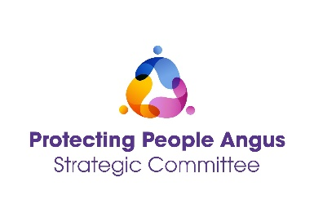
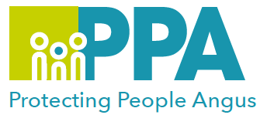

Protecting People Awareness Raising Session

DATE | TIME | LOCATION
21 January 2026 | 09.30 - 12:00 | Training Room, Angus House  Orchardbank, Forfar
This level one training is aimed at all multi-agency professionals, carers or volunteers who have a role in supporting people at risk of harm.

This session will give an overview of Child Protection, Violence Against Women and Adult Protection, supporting you to understand/identify when someone maybe at risk of harm and what you need to do.

Training Facilitators: Protecting People Angus Team

Learning outcomes:

- Gain an understanding of types of harm or abuse.
- Reflection on your role in Protection work.
- How to respond to and record a disclosure.
- What This to avoid when involved in Protection work.
- Overview of Trauma Informed Practice.
- Identify when to you need to act.
- What to do next?

Audience:

This training is open to anyone who has a role in supporting people, within the Angus and Tayside area.

To book please use the following link: Protecting People Awareness Raising Session

