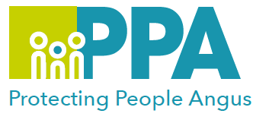
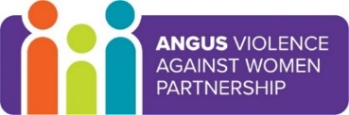
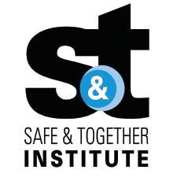

16 Days of Activism against Gender-Based Violence

Safe & Together in Education in Angus

27th November 2025 9.30am – 12.30pm

Angus House Training Suite, Forfar

Gender inequality is a root cause of violence against women and girls. Gender-based violence is committed disproportionality by men against women and covers a range of violence and abuse.
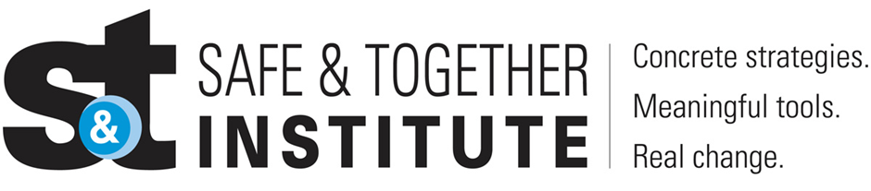

The Safe and Together model provides a framework for working in partnership with the non-offending parent; while holding the perpetrator accountable to achieve better outcomes for families. https://safeandtogetherinstitute.com/

Event hosts

Fiona Milne – Senior Practitioner Child Protection

Learning outcomes

- Raise awareness in identifying domestic abuse in all its forms.
- Understand the prevalence, nature and impact of domestic abuse.
- Understand the importance of accurate record keeping as a means of mapping perpetrator patterns.
- Understand the Safe & Together implementation plans here in Angus.

Audience

This learning session is for staff working in any education provision in Angus.

To book a place on the training: Link

