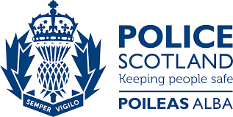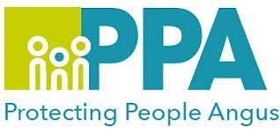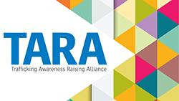

HUMAN TRAFFICKING AWARENESS RAISING EVENTS
Human trafficking is a complex crime which involves adults and children being traded and exploited for personal benefit and can include people being forced into labour or sexually abused. Victims can suffer lasting physical and psychological damage.
People in Angus may assume that Human Trafficking is something that happens elsewhere and as such our small Local Authority would not be affected. Unfortunately, this is not the case, with children and adults are potentially being placed at risk of harm in all areas. We all have a responsibility to recognise, understand and act where Human Trafficking maybe an issue.
This session will be delivered by Audrey Hand, Trafficking Awareness Raising Alliance (TARA) and Kate Philip from the National Human Trafficking Unit (NHTU), Police Scotland.
The session will cover:
• Indicators of human trafficking and sexual exploitation.
• Type of human trafficking.
• Financial impact and gain to the traffickers.
• Human Trafficking and Exploitation (Scotland) Act 2015.
• How to report human trafficking.
These sessions are suitable for all of Angus multi-agency staff who will be supporting individuals or encounter the public within their role.
DATE | TIME | LOCATION and Link | QR Code
3rd September 2025 | 10:30 – 13:00 | ANGUS HOUSE, TRAINING SUITE,  ORCHARDBANK BUSINESS PARK, FORFAR, DD8 1AN  Link | 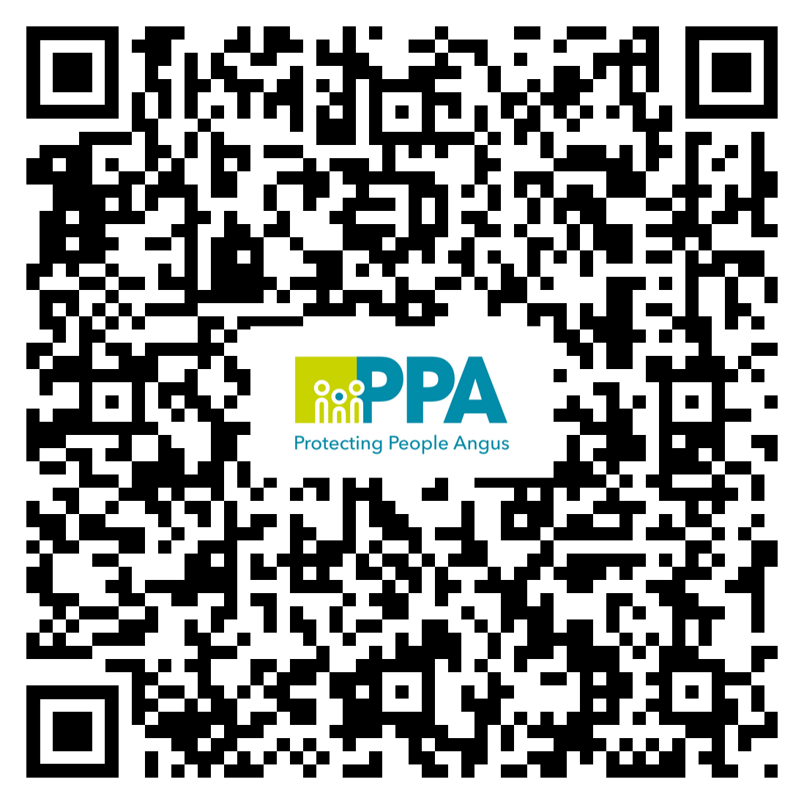
3rd December 2025 | 10:30 – 13:00 | ANGUS HOUSE, TRAINING SUITE,  ORCHARDBANK BUSINESS PARK, FORFAR, DD8 1AN  Link | 