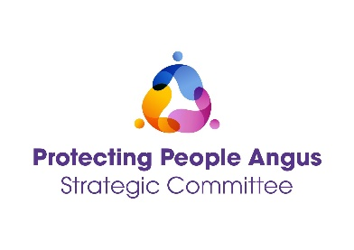

Care And Risk Management Training
(including Mock CARM)

Monday 9th June 2025 10am – 4pm
Tuesday 9th September 2025 10am – 4pm
Monday 15th December 2025 10am – 4pm

Bruce House, Arbroath

These events will provide an opportunity to explore and reflect on the roles of multi-agency professionals, within a CARM Meeting.

Event hosts

Protecting People Angus
Angus Council, Children Families & Justice – Quality Improvement and Review Team
Hillcrest Futures – Mental Health Peer Support Service

Learning outcomes
- Raise confidence and gain invaluable first-hand experience of participating in a CARM.
- Gain understanding of the process of the CARM while in a safe and supportive environment.
- Explore roles and responsibilities, thresholds, managing risk and professional curiosity/ challenge.
- Gain practical advice and feedback on what will be expected of you, while attending a CARM Meeting.

Audience
This event is being offered to Angus Council Education staff, Police, Health, Third Sector and Angus Council SW.

Sign Up Via Eventbrite using the link below.

9 June 2025 - Link
9 September 2025 - Link
15 December 2025 – Link

