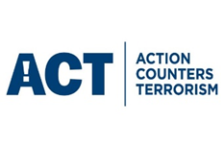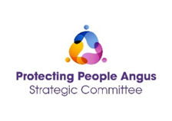

Action Counters Terrorism (ACT)
Multi-Agency Awareness Raising Session
The UK Counter-Terrorism (CONTEST) Strategy was developed to address threats that Scotland and the rest of the UK face from a range of extremist and terrorist ideologies, groups and individuals.
Prevent, Pursue, Protect and Prepare are strands of this strategy.

ACT Awareness is a counter-terrorism awareness program designed for all UK-based organizations and individuals. It provides nationally accredited corporate guidance to help understand and mitigate against current terrorist methodology

Multi-Agency Awareness Raising Session
DATE | TIME | LOCATION
21st May 2025 | 09:30 – 13:30 | Brechin High School, Duke Street, Brechin, DD9 6LB

This session is to be facilitated by:
DC Lindsey Souter,
Police Scotland, Counter Terrorism Security Advisor
PC Kayleigh Skinner,
Police Scotland, Counter Terrorism Liaison Officer
Abi Kyle
Prevent Adviser – Home Office, Scotland
The course is an interactive workshop designed to raise awareness of:
- Counter Terrorism issues,
- Improve security culture,
- Assist delegates with understanding the role they play,
- Increase confidence when responding to an incident,
- The Angus development within the strategy.

Please use the following link to book a space:
https://www.eventbrite.co.uk/e/action-counters-terrorism-tickets-1311610043949

