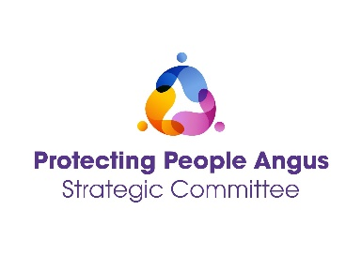
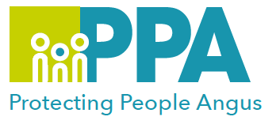

Protecting People Awareness Raising Session

DATE | TIME | LOCATION
30 January 2025 | 14:00 – 16:30 | Training Room, Angus House  Orchardbank, Forfar
25 March 2025 | 09:30 – 12:00 | G1, Bruce House  Wellgate, Arbroath
24 June 2025 | 09:30 - 12:00 | G1, Bruce House  Wellgate, Arbroath
24 September 2025 | 14:00 - 16:30 | Training Room, Angus House  Orchardbank, Forfar
19 November 2025 | 14:00 - 16:30 | Training Room, Angus House  Orchardbank, Forfar
This level one training is aimed at all multi-agency professionals, carers or volunteers who have a role in supporting people at risk of harm.

This session will give an overview of Child Protection, Violence Against Women and Adult Protection, supporting you to understand/identify when someone maybe at risk of harm and what you need to do.

Training Facilitators: Protecting People Angus Team

Learning outcomes:

- Gain an understanding of types of harm or abuse.
- Reflection on your role in Protection work.
- How to respond to and record a disclosure.
- What This to avoid when involved in Protection work.
- Overview of Trauma Informed Practice.
- Identify when to you need to act.
- What to do next?

Audience:

This training is open to anyone who has a role in supporting people, within the Angus and Tayside area.

To book please use the following link or click on your preferred date of training above:

Thursday 30 January 2025 - https://www.eventbrite.co.uk
Tuesday 25 March 2025 - https://www.eventbrite.co.uk
Tuesday 24 June 2025 - https://www.eventbrite.co.uk
Wednesday 24 September 2025 - https://www.eventbrite.co.uk
Wednesday 19 November 2025 - https://www.eventbrite.co.uk

