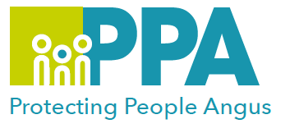
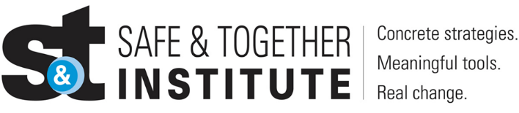

Safe & Together Lunchtime Learning Sessions
2025 – 2026 Programme

SESSION | DATE | TIME | LOCATION
Introduction to Domestic Abuse Good Practice | 1 April 2025 | 12 – 1pm | MS Teams
Domestic Abuse Typologies | 6 May 2025 | 12 – 1pm | MS Teams
Good Domestic Abuse Practice – Prompt Tool | 3 June 2025 | 12 – 1pm | MS Teams
Domestic Abuse and the Role of Housing | 1July 2025 | 12 – 1pm | MS Teams
Domestic Abuse risk assessment tool and referrals to MARAC | 5 August 2025 | 12 – 1pm | MS Teams
Mapping Perpetrators Behaviour | 2 September 2025 | 12 – 1pm | MS Teams
Report Writing and Assessment | 7 October 2025 | 12 – 1pm | MS Teams
Partnering with Survivors of Domestic Abuse & Mapping Survivor Strengths | 4 November 2025 | 12 – 1pm | MS Teams
Risk Assessment V’s Safety Planning | 2 December 2025 | 12 – 1pm | MS Teams
Working with Perpetrators as Fathers to try to effect Change | 3 February 2026 | 12 – 1pm | MS Teams
Support for Children having Experienced Domestic Abuse | 3 March 2026 | 12 – 1pm | MS Teams
Angus Safe & Together Champions have developed a series of Learning sessions they will deliver once a month to all staff in Angus. You are welcome to come to as many of these as you wish to.
The aims of the Programme are:
- To share our learning as Safe & Together Champions and practitioners working with children, young people & families
- To create a safe space to allow practitioners to share their thoughts, feelings and practice dilemmas around working with Domestic Abuse
- To support our colleagues in Angus in order to improve outcomes for families where Domestic Abuse is present.
Training Facilitators:

Angus Council Safe & Together Champions

Audience:

This training is open to anyone in a multi-agency supporting role, within the Angus and Tayside area.

To see more information about each session and to book your please click on your preferred session name or here https://www.eventbrite.com

