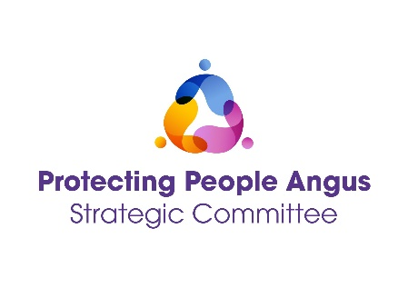
PROTECTING PEOPLE ANGUS STRATEGIC COMMITTEE (PPASC)
CUPPY WITH THE COMMITTEE

DATE | TIME | LOCATION
Friday 16 May 2025 | 09.30 – 11.30 | G1, Bruce House  Wellgate, Arbroath, DD11
Friday 7 Nov 2025 | 09.30 – 11.30 | Boardroom, Angus House  Orchardbank, Forfar, DD8

Are you a multi-agency professional working within Child/Adult Support and Protection or Violence Against Women & Girls in Angus?

Come along for a cuppa with members of the Protecting People Angus Strategic Committee.

- Learn more about the PPASC and how it supports the work you do.

- Feedback on how policy is working in practice.

- Hear about the delivery groups that multi-agency staff can join to influence the work of the committee:
- Data
- Self-Evaluation and Continuous Improvement (SECI)
- Practice and Policy
- Workforce Learning and Development
- Preventions

Please use the following links to book a place:
Friday 16 May 2025 – https://www.eventbrite.co.uk
Friday 7 Nov 2025 - https://www.eventbrite.co.uk

