

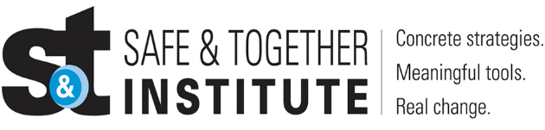

Good Practice in Domestic Abuse and Safe & Together Principles
Multi-Agency Learning Session
DATE | TIME | LOCATION
Tuesday 21 January 2025 | 09:30 – 10:30 | MS Teams
Thursday 20 March 2025 | 16:00 – 17:00 | MS Teams
Wednesday 21 May 2025 | 12:30 – 13:30 | MS Teams
Wednesday 27 August 2025 | 09:30 – 10:30 | MS Teams
Tuesday 14 October 2025 | 16:00 - 17:00 | MS Teams
Thursday 11 December 2025 | 13:00 – 14:00 | MS Teams

The Safe and Together model is based on three key principles: Keeping children Safe & Together with their non-abusive parent, ensuring safety, healing from trauma, stability, and nurturance. Partnering with the non-abusive parent as a default position ensuring efficient, effective, and child-centred practice. https://safeandtogetherinstitute.com/

The Safe & Together Model fills the gaps in knowledge/practice and by integrating this model, communities in Angus can work more effectively to support women and children, helping them live free from abuse.

Gender inequality is a root cause of violence against women and girls. Gender-based violence is committed disproportionality by men against women and covers a range of violence and abuse.

Event hosts

Angus Safe and Together Champions.

Learning outcomes

- To learn about the principles of Safe and Together and how this applies to practice.
- To gain an understanding and need to engage with survivors and preparators of DA
- To share our learning as Safe & Together Champions and practitioners working with children, young people & families
- To create a safe space to allow practitioners to share their thoughts, feelings and practice dilemmas around working with Domestic Abuse
- To support our colleagues in Angus in order to improve outcomes for families where Domestic Abuse is present.

Audience

This multi-agency learning session will be ideal for any worker/volunteer in Angus.

To book please use the following link: https://www.eventbrite.co.uk

“The more that we choose not to talk about domestic violence, the more we shy away from the issue, the more we lose.”
― Russell Wilson
www.everydaypower.com/domestic-violence

