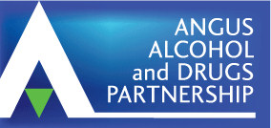 | NEWSLETTER  National and local information that  may be of interest to members.  DECEMBER 2024
Wishing you all a Merry Christmas & Best Wishes for the New Year!

from the ADP Support Team
LOCAL
- See Angus ADP Training schedule at the end of this newsletter.
- Angus Integrated Drug and Alcohol Recovery Service (AIDARS) celebrated moving into their new base at Bruce House, Arbroath in time for Christmas! Unfortunately, only one team member was allowed to be The Grinch this year…all tasteless Christmas jumpers were subjected to a Taste Tax, with proceeds going to local food banks!

Well Done AIDARS!

Please note AIDARS new address is: Bruce House, Wellgate, Arbroath DD11 3TP
Telephone Number remains the same: 01241 822502

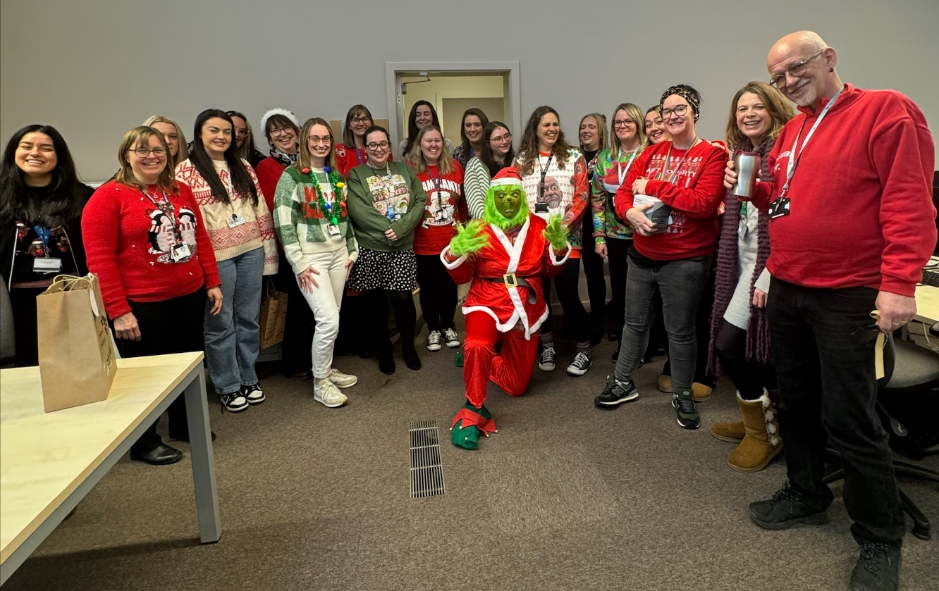

Angus Services Festive Opening Hours and Out of Hours Support

Christmas Week
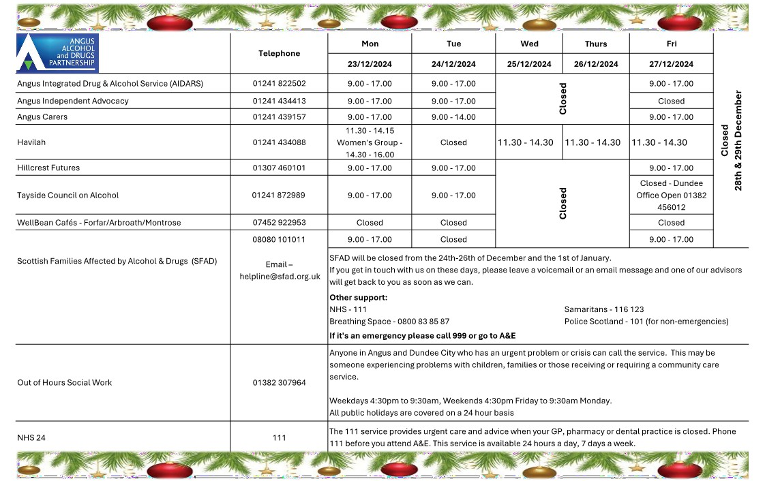

New Year Week
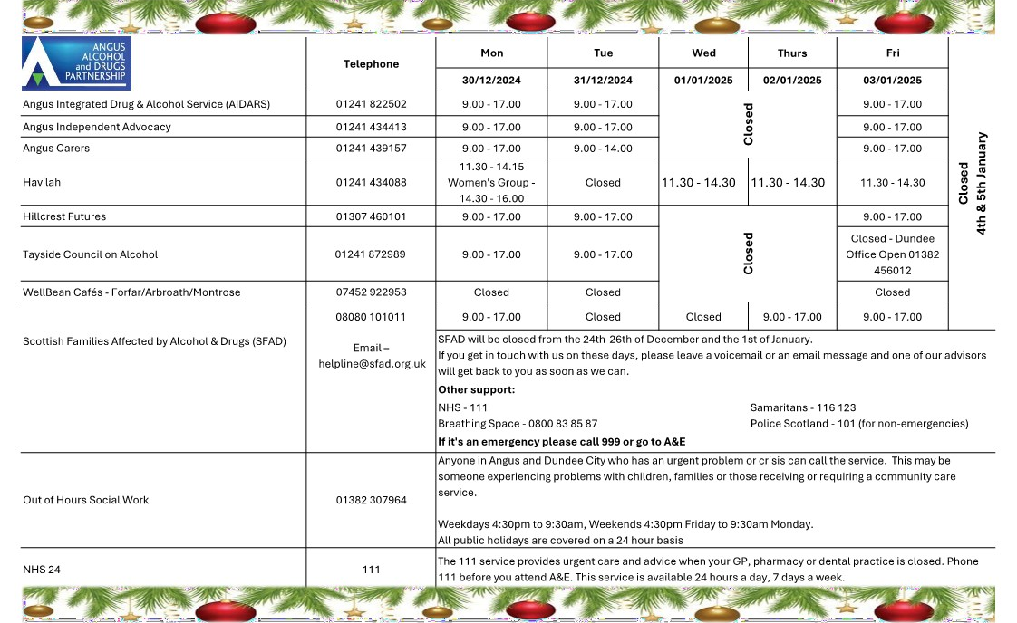

- Podcasts – links below to the For Families by Families poscasts
Ketamine
Cocaine

- For Families by Families Event
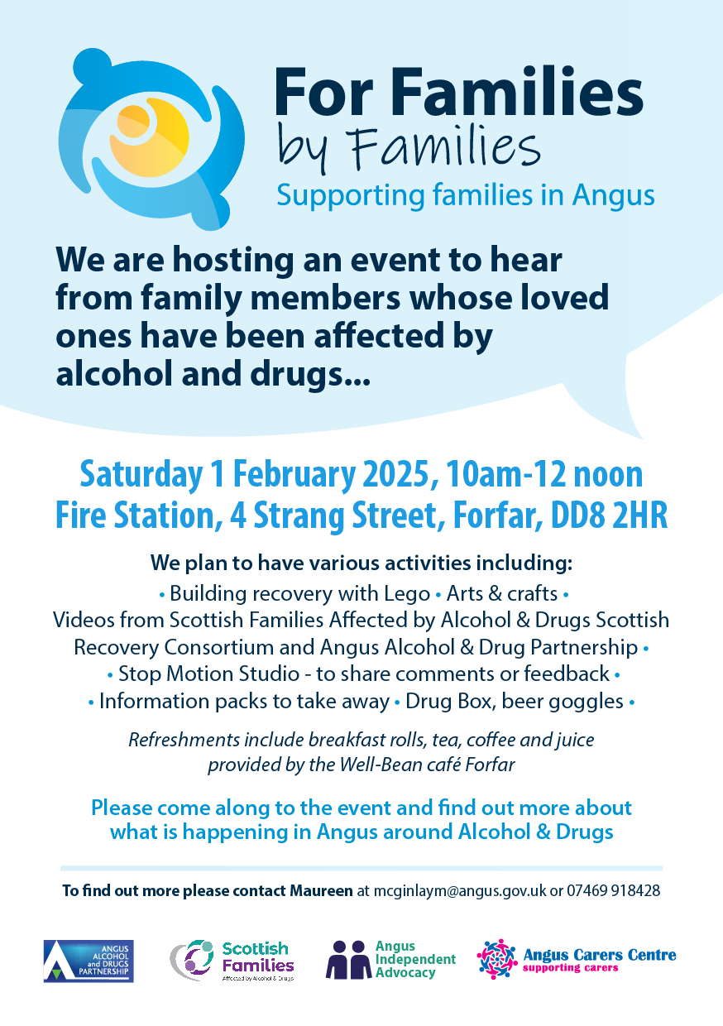

NATIONAL

- Take Ket, Let’s Chat
- The Drug Science Podcast

Please also refer to the PPA Newsletter for other training opportunities - click this link to receive the newsletter direct to your mailbox or email ProtectingPeopleAngus@angus.gov.uk to request being added to the subscriber list.
ADP TRAINING

Click on the title below to find out more or book a place.

2025
JANUARY
14/01/2025 | Overdose Awareness & Naloxone Training | 14.30-16.00 | Forfar
22/01/2025 | Multiple Risk | 09:15 – 13:30 | SDF Online
23/01/2025 | Lunchtime Learning - Homeless Prevention Team | 12.30-13.00 | Microsoft Teams
29/01/2025 | Lunchtime Learning – Skills & Employability | 12.30-13.00 | Microsoft Teams

Ho Ho Ho

Merry Christmas!


