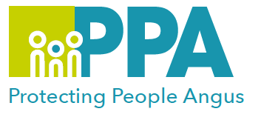
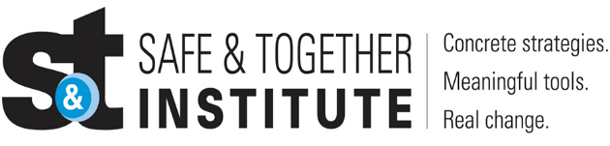
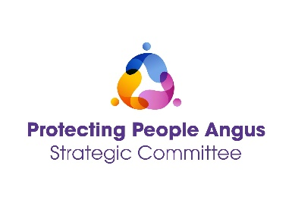

Best Practice in Domestic Abuse
Prompt/DA Typologies Card Tool
DATE | TIME | LOCATION
12 February 2025 | 12:30 - 13:30 | MS Teams

Please save the date in your calendar as the link will be sent by the organiser shortly before the session is held.

Angus Safe & Together Champions have developed a series of Learning sessions they will deliver once a month to all staff/volunteers in Angus. You are welcome to come to as many of these as you wish to.

The aim of this session is:
- To gain an understanding and need to engage with survivors and preparators of DA
- To share the benefits of using the DA Prompt and Typology Card in practice.
- To share our learning as Safe & Together Champions and practitioners working with children, young people & families
- To create a safe space to allow practitioners to share their thoughts, feelings and practice dilemmas around working with Domestic Abuse
- To support our colleagues in Angus in order to improve outcomes for families where Domestic Abuse is present.

Training Facilitators:
Angus Safe and Together Champions

Please use the following link to book a place on the training: https://www.eventbrite.co.uk

“The more that we choose not to talk about domestic violence, the more we shy away from the issue, the more we lose.” ― Russell Wilson
https://everydaypower.com/domestic-violence-quotes/

