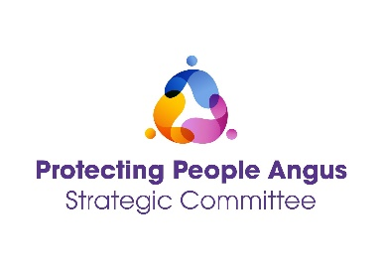
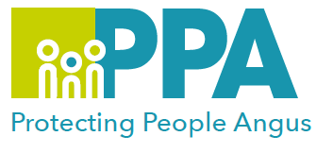
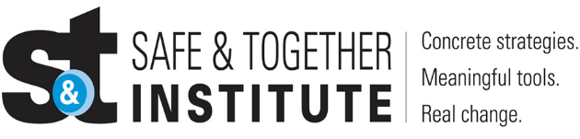

Best Practice in Domestic Abuse
Domestic Abuse and the role of Housing
DATE | TIME | LOCATION
Tuesday 15 April 2025 | 12:30 - 13:30 | MS Teams

Please save the date in your calendar as the link will be sent by the organiser shortly before the session is held.

“Our work is grounded in the idea that latent in child welfare systems, is the potential to be a powerful ally to adults and children harmed by a domestic violence perpetrator’s behaviours. Systems are most effective when they say to the adult survivor, “We want to help you and your children be safer and healthier. Tell us what we can do to help.” - Safe and Together Institute

Angus Safe & Together Champions have developed a series of Learning sessions they will deliver once a month to all staff in Angus. You are welcome to come to as many of these as you wish to. The aim of the programme is:
- To share our learning as Safe & Together Champions and practitioners working with children, young people & families
- To create a safe space to allow practitioners to share their thoughts, feelings and practice dilemmas around working with Domestic Abuse
- To support our colleagues in Angus in order to improve outcomes for families where Domestic Abuse is present.

Training Facilitators:
Angus Council Housing Safe and Together Champions

To book a place on the training: https://www.eventbrite.co.uk

“The more that we choose not to talk about domestic violence, the more we shy away from the issue, the more we lose.” ― Russell Wilson
https://everydaypower.com/domestic-violence-quotes/

