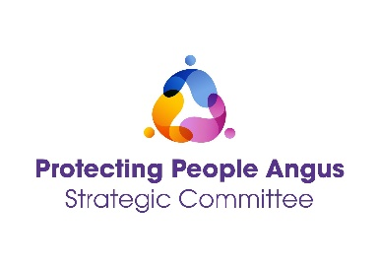
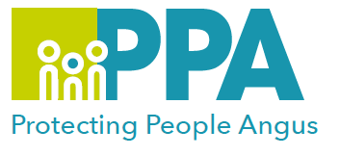
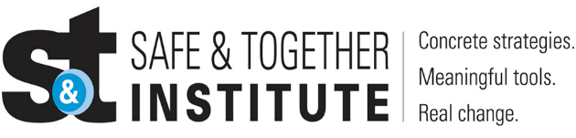

Good Practice in Domestic Abuse
Report Writing and Assessment Session

DATE | TIME | LOCATION
Tuesday 11 March 2025 | 12:30 – 13:30 | MS Teams

Please save the date in your calendar as the link will be sent by the organiser shortly before the session is held.

The Safe and Together model provides a framework for working in partnership with the non-offending parent, while holding the perpetrator accountable to achieve better outcomes for families. https://safeandtogetherinstitute.com/

Angus multi-agency, Safe & Together Champions, have developed a series of Learning sessions they will deliver once a month to all staff/volunteers in Angus.

Training Facilitators:

Angus Safe and Together Champions

Learning Outcomes

- Good practice Safe & Together Principles and Core Components
- Focus on assessment and report writing in relation to Safe & Together
- Consider how to incorporate S&T principles into assessment and report writing, including:

- perpetrator patterns of behaviour, their engagement and willingness to make changes.
- taking a strength-based approach with the survivor.

Audience

This multi-agency learning session will be ideal for any worker/volunteer, practicing in Angus, who may have contact with survivors of DA. The knowledge in this event will help to support you to support survivors of DA.

Please use the following link to book a place on the training: https://www.eventbrite.co.uk

Gender inequality is a root cause of violence against women and girls. Gender-based violence is committed disproportionality by men against women and covers a range of violence and abuse.

