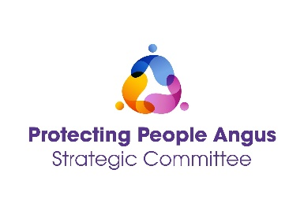
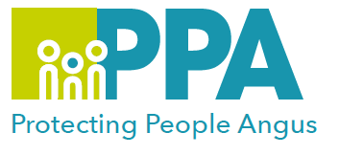
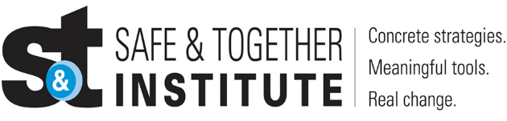

Good Practice in Domestic Abuse
Mapping Perpetrator Patterns of Behaviour
DATE | TIME | LOCATION
15 May 2025 | 12:30 - 13:30 | MS Teams

Please save the date in your calendar as the link will be sent by the organiser shortly before the session is held.

The Safe and Together model provides a framework for working in partnership with the non-offending parent, while holding the perpetrator accountable to achieve better outcomes for families. https://safeandtogetherinstitute.com/

Angus multi-agency, Safe & Together Champions, have developed a series of Learning sessions they will deliver once a month to all practitioners/volunteers working in Angus and Tayside.

Training Facilitators:

Angus Multi-Agency Safe and Together Champions.

Learning Outcomes

- Context of Domestic Abuse (DA) in Scotland and Angus, including Typologies and Failure to Protect Discourse
- Good practice Principles - Safe & Together Principles and Core Components
- Perpetrator Pattern Based Approach
- Partnering with Survivors
- Actions Taken by Perpetrator to Harm Children
- Mapping Perpetrator Pattern of Behaviour

Audience

This multi-agency learning session will be ideal for any worker/volunteer, practicing in Angus and Tayside, who may have contact with survivors of DA. The knowledge in this event will help to support you to support survivors of DA.

To book a place on the training please use following link: https://www.eventbrite.co.uk

Gender inequality is a root cause of violence against women and girls. Gender-based violence is committed disproportionality by men against women and covers a range of violence and abuse.

