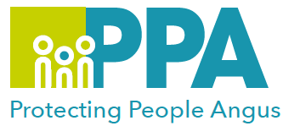

Domestic Abuse (Coercive Control) and the Law

DATE | TIME | LOCATION
11 February 2025 | 10:00 -12:00 | MS Teams
18 September 2025 | 10:00 -12:00 | MS Teams

Please choose only one date. Please save the date in your calendar as the link will be sent by the organiser shortly before the session is held.

Facilitator

This session is being facilitated by Marianne Osborne who has worked with Renfrewshire Women’s Aid since 2002, and who has a wealth of experience and knowledge around the area of Domestic Abuse both at a local and national level.

Learning outcomes

- To introduce and gain an understand of the Domestic Abuse (Scotland) 2018 Act, and its implementation into practice.
- Exploration of the Police Scotland disclosure system.
- Gain an understand of the barriers to reporting using domestic abuse legislation.
- To understand how civil and criminal legislation on domestic abuse interacts and where the gaps are.
- To highlight the role of the services and how this may impact on practice.

Audience

This training is open to all multiagency staff that work in Angus and Tayside, who have a working understanding of Domestic Abuse.

To book please use the following link: https://www.eventbrite.co.uk
