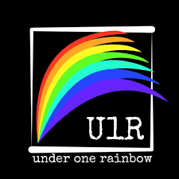
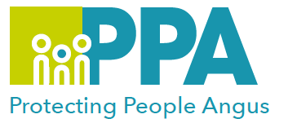

LGBTQIA+ Multi-agency Awareness Raising Session

DATE | TIME | LOCATION
Thursday 27 February 2025 | 09:30 – 12:30 | G1, Bruce House  Wellgate, Arbroath
Wednesday 16 July 2025 | 09:30 -12:30 | Training Suite, Angus House  Orchardbank, Forfar
Wednesday 22 October 2025 | 09:30 – 12:30 | G1, Bruce House  Wellgate, Arbroath
Please book one date

This face-to-face training session is being facilitated by Under One Rainbow, who are a local Angus organisation offering a range of services to LGBTQIA+ young people, family/friends, and the larger community generally.

Under One Rainbow was founded in 2022 following discussions about the extra difficulties that young LGBTQIA+ people and their families sometimes face and the lack of available highly confidential support.

Facilitator:

Shaun Taylor, Angus practitioner Under One Rainbow

Learning Outcomes:
- A greater awareness of LGBT issues
- A wider understanding of language and identities
- An opportunity to explore potential scenarios for further examination and implementation beyond the training.
- An understanding of what is going on for young LGBTQIA+ in Angus.

To book please use the following link or click on your preferred date of training above:

Thursday 27 February 2025 – https://www.eventbrite.co.uk
Wednesday 16 July 2025 – https://www.eventbrite.co.uk
Wednesday 22 October 2025 - https://www.eventbrite.co.uk

