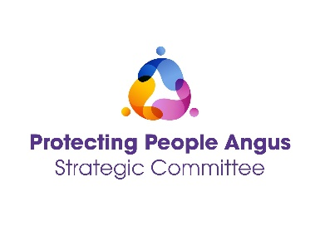

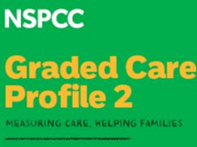

Graded Care Profile (GCP2) Tool
Full Day, Face to Face Training for Multi-Agency Staff
DATE | TIME | LOCATION
27 March 2025 | 09:30 – 15:30 | G1, Bruce House  Wellgate, Arbroath
02 September 2025 | 09:30 – 15:30 | G1, Bruce House  Wellgate, Arbroath
Please choose only one date

What is the Graded Care Profile 2 (GCP2)?

The Graded Care Profile 2 (GCP2) is a tool designed to help practitioners take a strength-based approach to measure the quality of care a child is receiving, and support professionals to identify neglect, where this is an issue.
Neglect can have damaging effects on a child’s health, development, and education, and later in life can put them at risk of depression, substance abuse and even suicide attempts (Norman et al, 2012).

Learning outcomes:

Gain an understanding of how to effectively use this tool to support families, enabling professionals to:

- Measure the quality of care being provided to children.
- Identify where children require further support and whether the level of care received needs to be improved.
- Implement a constructive working relationship with families.
- Increase your confidence in decision making at all levels.
- Promote multi-agency working creating a common language.

Audience:

This training is open to all multi-agency staff working with children and families within the Angus area.

To book please use the following link: https://www.eventbrite.co.uk

