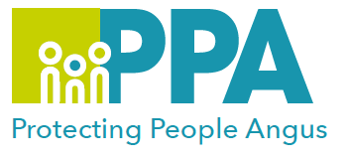

Getting It Right For Every Child (GIRFEC)
Multi-Agency Training

DATE | TIME | LOCATION
Thursday 30 January 2025 | 09.00 – 12.30 | G1, Bruce House  Wellgate, Arbroath
Tuesday 4 February 2025 | 09.00 – 12.30 | Training Suite, Angus House  Orchardbank, Forfar

This face-to-face event (please, only choose one date)

Learning Outcomes:

- Gain an understanding of what has changed following the GIRFEC refresh.
- Clarify how GIRFEC can be delivered through the Continuum of Need process in Angus using practical scenarios.
- Explore relevant resources and tools.
- Provide insight on rights-based approaches to planning and information sharing.
- Provide practical advice on how to chair and record meetings effectively.

Professionals taking part in this session are required to have completed the GIRFEC module either on Always Learning or Turas.

Audience:

Open to professionals across agencies, working in Angus and Tayside, and delivering the Named Person and Lead Professional roles.

To book please use the following link or click on your preferred date of training above:
Thursday 30 January 2025 - https://www.eventbrite.co.uk
Tuesday 4 February 2025 - https://www.eventbrite.co.uk
