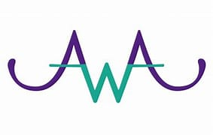


Domestic Abuse/Coercive Control Risk Assessment and Safety Planning

Domestic Abuse - Risk Assessment and Safety Planning Awareness Raising Sessions
These learning sessions aim to raise awareness of Domestic Abuse, the MARAC model and risk assessment and safety planning in high-risk domestic abuse situations. These sessions are aimed at all staff who provide support to people in Angus.
These sessions will provide:
- An overview of Domestic Abuse/Coercive Control
- An understanding of the risk attached to Domestic Abuse/Coercive Control
- A basic awareness of carrying out Risk Assessment around Domestic Abuse/Coercive Control
- A basic awareness around Immediate Safety Planning and how to raise a concern
- An overview of the MARAC process and how to refer to MARAC
These sessions will be presented by Angus Women's Aid and Police Scotland MARAC Coordinator.
Bookings for these sessions can be made via Eventbrite via the links below:
Tuesday 17th September 0930 – 1230 – Angus House training suite, Forfar
Tuesday 12th November 0930 - 1230 – Bruce House G1, Arbroath SOLD OUT
Thursday 28th November 1330 – 1630 – Bruce House G1, Arbroath
Thursday 12th December 1330 - 1630 – Angus House Training Suite, Forfar SOLD OUT
