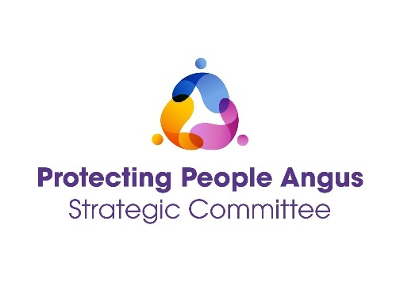
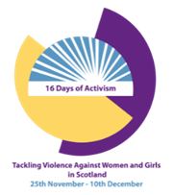
16 DAYS OF ACTION AGAINST GENDER BASED VIOLENCE

Forced Marriage, Honour Based Violence
and Female Genital Mutilation Conference

03 DECEMBER 2024

10:00 – 12:30

THE SANCTUARY, ST ANDREWS CHURCH
21 HAMILTON GREEN, ARBROATH DD11 1JG

As part of 16 Days of Action Against Gender Based Violence – please join us for a half day conference focussed on Forced Marriage, Honour Based Violence and Female Genital Mutilation.

During the morning, we will hear from guest speakers and relaunch and raise awareness of the Dundee and Angus Protocols for Forced Marriage, Honour Based Violence and Female Genital Mutilation.

We will be welcoming speakers:

Mariam Ahmed, Chief Executive Officer,
Anima: The Muslim Women’s Resource Centre
&
Girijamba Polubothu, Chief Executive Officer at Shakti Women’s Aid

This conference is open to Multi-agency practitioners working with and supporting people in the Angus and Dundee areas.

To book a place on the conference, please use the following link:
https://www.eventbrite.co.uk

