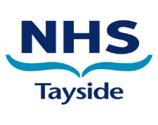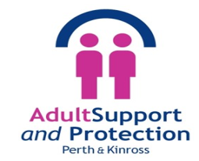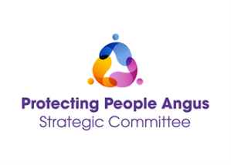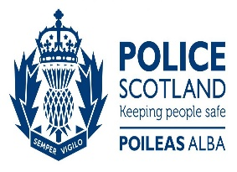

16 days of Activism against
Gender Based Violence 25 November – 10 December 2025
‘Every conversation matter’s’

HUMAN TRAFFICKING
03 December 2024 12:00 – 13:30

To join, click here (MS Teams link) and add to your diaries

Join this multi-agency webinar for staff with guest speaker Audrey Hand, a training officer with Trafficking Awareness Raising Alliance (TARA) to find out more about Human Trafficking, how to access advice, support and guidance for women who may have been trafficked and exploited.

Public Protection - ‘It’s everyone’s business’.
Together we can help to keep people safe and protected from harm.

