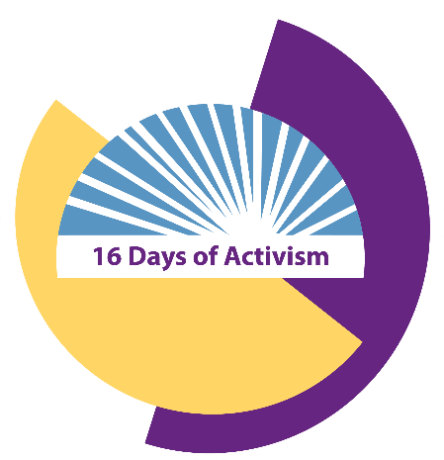
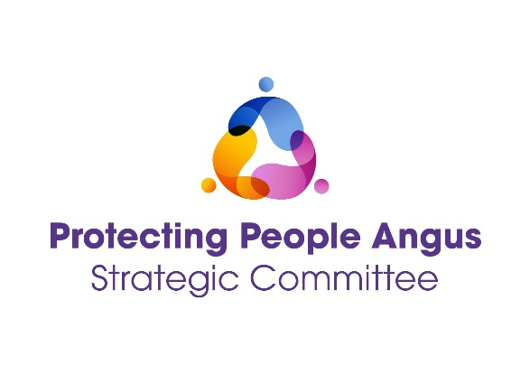

16 DAYS OF ACTION AGAINST GENDER BASED VIOLENCE

Banaz: A Love Story - Film Screening and Discussion

25 November 2024

1pm – 3.30pm

MacNiven Room, The Hub at Friockheim
Eastgate, Friockheim, DD11 4TG

Together with Angus Women’s Aid and Dundee and Angus WRASAC please join us for a screening of the film
‘Banaz: A Love Story’, a documentary film chronicling the brutal Honour Killing of Banaz Mahmod, a young British Kurdish woman in London, killed by her own family for choosing a life for herself.

The screening is part of our programme of events for
16 Days of Action Against Gender Based Violence
25 November – 10 December 2024.

The screening will be followed by a discussion of the film and
will include teas and coffees.

This is a community event. Everyone is welcome to book a place by using the following link:
https://www.eventbrite.co.uk

