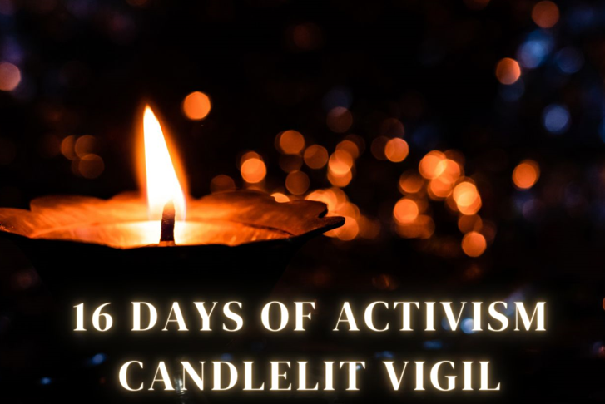

16 Days of Action Against Gender-based Violence Vigil

Monday 9 December 2024
17.30 – 19.30pm
Arbroath High School
Keptie Road, Arbroath, DD11 3BN

Join us for a candlelit vigil as we come together to honour the lives of women tragically lost to gender-based violence in the past year.

Shockingly, statistics reveal that in the UK, one woman is killed by a man every three days. Let us unite in remembrance, solidarity, and a shared commitment to combating this devastating issue, lighting a path toward a safer, more compassionate world for all.

The evening will feature speakers, music and a moment of reflection followed by refreshments. Please ensure to wrap up warmly
for the December weather.

To book a place at the vigil, please use the following link:

https://www.eventbrite.co.uk


