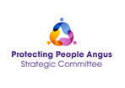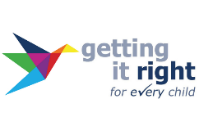

Getting It Right For Every Child (GIRFEC)
Multiagency Training

Date | Time | Venue
5 September 2024 | 9.00am – 12.30pm | Brechin Community  Campus Theatre,  Duke Street, Brechin DD9 6LB
26 September 2024 | 9.00am – 12.30pm | Angus House,  Training Suite, Orchardbank Business Park, Forfar DD8 1AX

This face-to-face event (please, only choose one date) is open to professionals across agencies, working in Angus and delivering the Named Person and Lead Professional roles.

The aim of the event is to:

- Gain an understanding of what has changed following the GIRFEC refresh
- Clarify how GIRFEC can be delivered through the Continuum of Need process in Angus using practical scenarios
- Explore relevant resources and tools
- Provide insight on rights-based approaches to planning and information sharing
- Provide practical advice on how to chair and record meetings effectively

Professionals taking part in this session are required to have completed the GIRFEC module either on Always Learning or Turas.

To book please use the links:

Brechin Community Campus: https://buytickets.at/anguscouncil2/1308158

Angus House Training Suite: https://buytickets.at/anguscouncil2/1308167

