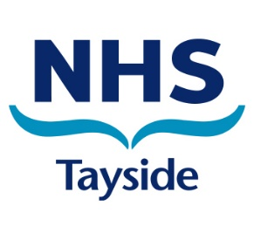
WEBINAR
COERCIVE CONTROL and UNDUE PRESSURE
22 May 2024 10:00 – 11:45
MS TEAMS
SAVE THE DATE - JOINING DETAILS WILL BE SHARED IN DUE COURSE

Join this multi-agency webinar with guest speaker Nairn Young to find out more about:

Adult Support and Protection legislation, recognising the signs of coercive control and undue pressure and how to support people experiencing controlling behaviour.

Public Protection - ‘It’s everyone’s business’.
Together we can help to keep people safe and protected from harm.

