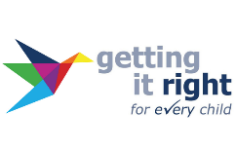

Getting It Right For Every Child (GIRFEC)
Multiagency Training

Date | Time | Venue
15 May 2024 | 9.00am – 12.30pm | Angus House,  Training Suite
12 June 2024 | 9.00am – 12.30pm | Brechin Community  Campus Theatre

This face-to-face event (please, only choose one date) is open to professionals across agencies, working in Angus and delivering the Named Person and Lead Professional roles.

The aim of the event is to:

- Gain an understanding of what has changed following the GIRFEC refresh
- Clarify how GIRFEC can be delivered through the Continuum of Need process in Angus using practical scenarios
- Explore relevant resources and tools
- Provide insight on rights-based approaches to planning and information sharing
- Provide practical advice on how to chair and record meetings effectively

Professionals taking part in this session are required to have completed the GIRFEC module on Always Learning.

To book please use the Ticket Tailor links below:

Forfar: https://buytickets.at/anguscouncil2/1196866
Brechin: https://buytickets.at/anguscouncil2/1196919

