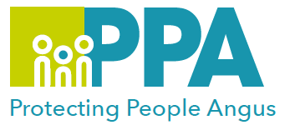


Angus Violence Against Women (AVAWP)

Domestic Abuse (Coercive Control) and the Law

Wednesday 20 March 2024, 09.30-12:00
or
Wednesday 5 June 2024, 09:30-12:00

via MS Teams

This session is being facilitated by Marianne Osborne who has worked with Renfrewshire Women’s Aid since 2002, and who has a wealth of experience and knowledge around the area of Domestic Abuse both at a local and national level.

Learning outcomes

- To introduce and gain an understand of the Domestic Abuse (Scotland) 2018 Act, and its implementation into practice.
- Exploration of the Police Scotland disclosure system.
- Gain an understand of the barriers to reporting using domestic abuse legislation.
- To understand how civil and criminal legislation on domestic abuse interacts and where the gaps are.
- To highlight the role of the services and how this may impact on practice.

This training is open to all multiagency staff that work in Angus, who have a working understanding of Domestic Abuse.

To book a place on the training use the following link: Link

