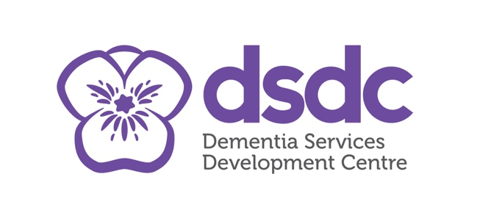

Adult Protection Day 2022
David Wilson-Wynne
ASP, Living Well and Dementia
Friday 23rd of February 2024, 09.30-12.30, MS Teams
Tuesday 27th of February 2024, 09.30-12.30, Angus House, Training Suite.

David Wilson-Wynne is the Senior Dementia Consultant at Dementia Services Development Centre, faculty of social sciences, University of Stirling. He has had an interest in Dementia research and working with individuals with a diagnosis of dementia for many years.

David will explore the Human Rights elements of working with services and individuals diagnosed with a dementia. Using scenario-based work and examining trends will support the learning within the session.
David will explore Dementia care and policies, using the biopsychosocial model and examining how we can make improvements in practice within the Dementia field. In studying the shift in communication needs with people with Dementia, there is a drive to be more consistent in the level of support needed, David aims to cover this within this session.

The session will include an opportunity to ask questions.
This training is open to all multiagency staff working in Angus.

Please use the link below to book a space:

- 23 February 2024 : Link

- 27 February 2024 : Link

