

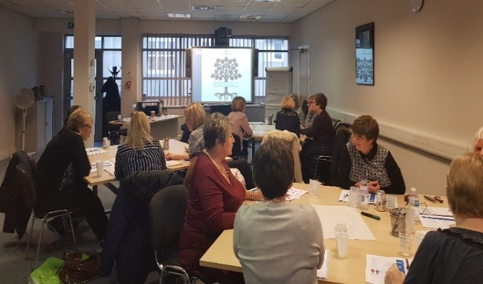
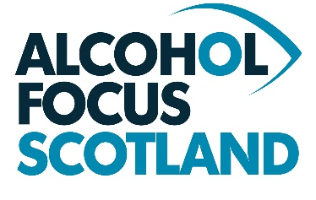
What Learners say …
"Great exercises which made the course interesting and relevant, enjoyed participation aspect of the course, engaging delivery".
“Excellent training opportunity, Very informative and knowledgeable trainers”.
"Fun and interactive course with good group activities to keep you engaged, course trainer approachable and well presented".

Learning Outcomes
Participants will be able to:
- Describe alcohol as a substance and explore how it affects the body.
- Discuss the impact of alcohol on Scottish society.
- Increased knowledge and understanding of the health and social harms caused by alcohol
- Explore the impact of alcohol on children, young people and families
- Identify current policies and approaches being taken in response to alcohol harm.
- Apply a number of basic strategies to support those affected by alcohol.

Delivery method: Face to Face
(The training is especially useful for those working in supportive roles such as caring and support services, i.e. housing, addictions, community-based support services etc.)
When: Thursday 11th January (9.30 – 4.30)
Where: Alcohol Focus Scotland, 166 Buchanan St, Glasgow G1 2LW
Cost: £55.00 per person

Training Objective:
The aim of the workshop is to increase your understanding and knowledge of the impact that alcohol related harm has on individuals, others around them and wider society. Increased knowledge and understanding on health and social harms. The training will provide you with an increased confidence in supporting service users and signposting them to relevant services.

Irene Scullion
0141 572 6597
irene.scullion@alcohol-focus-scotland.org.uk
www.alcohol-focus-scotland.org.uk

Alcohol Affects Us All T raining
To find out more contact…

Alcohol Focus Scotland is a Registered Scottish Charity (SC009538) and a Company Limited by Guarantee (Scottish Company No. SC094096)

