
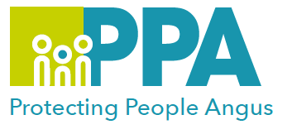

Angus Violence Against Women (AVAWP)
Wednesday 31 January 2024 9.30am – 12.30pm
via MS Teams
Engaging with Perpetrators of Domestic Abuse (Coercive Control)
Level 1 – General Knowledge

Gender inequality is a root cause of violence against women and girls. Gender-based violence is committed disproportionality by men against women and covers a range of violence and abuse that includes domestic abuse (coercive control).


Angus Council Justice Services are a member of AVAWP. As a single agency they have been developing their knowledge and understanding of domestic abuse and how to effectively engage with perpetrators. They are now able to share their learning to a wider audience and their learning from a Justice Service perspective is being made available for a multiagency audience.

Trainers - Laura Coburn / Jonathan Milne.

The learning outcomes from the session:
- To gain an understanding of domestic abuse
- To gain an understanding of the Safe and Together approach
- Who are perpetrators of domestic abuse?
- How do we work with perpetrators – skills and values that are involved, including the barriers to practice
- Justice Services 2:1 work, group work and opportunities for voluntary participation

This training is open to all multiagency staff that work in Angus.

To book a place on the training: Link

