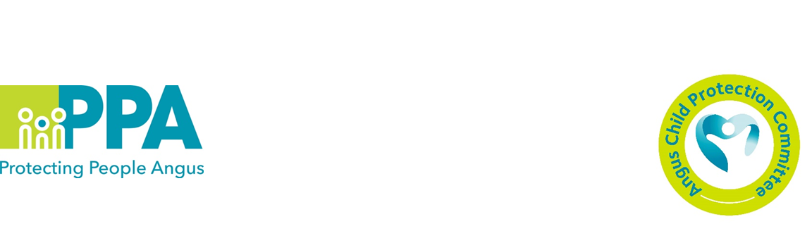

Reunification Practice Framework

This framework was developed by the NSPCC and is now being embedded within Angus Council Children and Families Services. This framework is an evidence-informed framework for return home practice. It was developed because of research findings about repeated findings of maltreatment and poor outcomes for children who returned home from being in local authority care.

The Reunification Practice Framework is not statutory guidance, it is a resource, a tool that LA’s can use to support practice improvement, it supports practitioners and managers to apply their professional judgement to complex decisions about whether a child should return home and identify what supports are needed if this is to become a safe and successful reality.

Outcomes
- Hear key messages from research
- Introduction to the Framework
- Know when the Framework can be used
- Know what is included in the Framework

Please book a place using the links below:

- Tuesday 16/01/24 10-12 G1 Bruce House, Arbroath
Link

- Wednesday 07/02/24 10-12 Board Room, County Buildings, Forfar
Link

- Monday 26/02/24 10-12 MS Teams
Link

