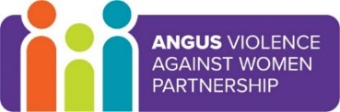
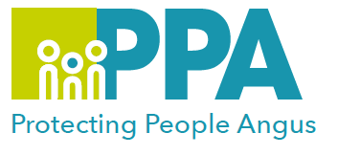
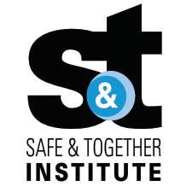
Angus Violence Against Women (AVAWP)

Angus Women’s Aid (AWA) Support for Children who have Experienced Domestic Abuse

Multi-Agency Learning Events on MS Teams

Wednesday 15 November 2023 1pm – 2pm
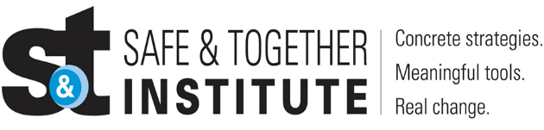

The Safe and Together model provides a framework for working in partnership with the non-offending parent, while holding the perpetrator accountable to achieve better outcomes for families. https://safeandtogetherinstitute.com/

Angus multi-agency, Safe & Together Champions, have developed a series of learning sessions they will deliver once a month to all practitioners/volunteers working in Angus.

Event Hosts
Angus Multi-Agency Safe and Together Champions.

Learning Outcomes
An overview of the services and support offered by Angus Women’s Aid (AWA) for children and young people who have experienced domestic abuse.

There will also be some case studies for participants to reflect on support they may offer to children and young people they work with.

Audience
This multi-agency learning session will be ideal for any worker/volunteer, practicing in Angus, who may have contact with survivors of domestic abuse. The knowledge in this event will help to support you to support survivors of domestic abuse.

To book please use the following link: Link

Gender inequality is a root cause of violence against women and girls. Gender-based violence is committed disproportionality by men against women and covers a range of violence and abuse.

