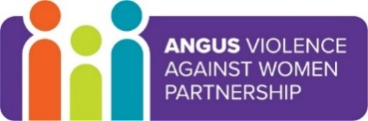
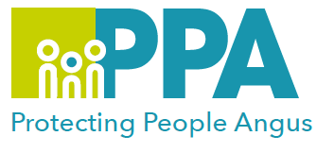
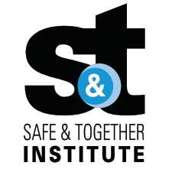

16 Days of Activism against Gender-based Violence

Safe & Together in Education in Angus

Tuesday 28 November 2023 9.30am – 12.30pm

Training Suite, Angus House, Forfar

Gender inequality is a root cause of violence against women and girls. Gender-based violence is committed disproportionality by men against women and covers a range of violence and abuse.
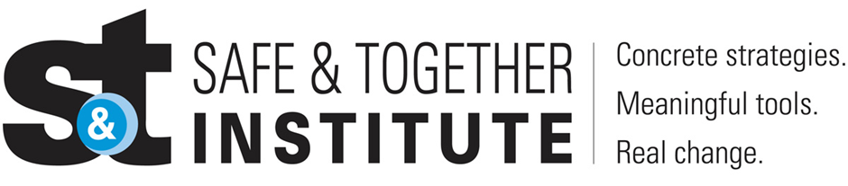

The Safe and Together model provides a framework for working in partnership with the non-offending parent; while holding the perpetrator accountable to achieve better outcomes for families. https://safeandtogetherinstitute.com/

Event hosts
Fiona Milne – Senior Practitioner Child Protection
Laura Winter – Team Leader Protecting People Angus.

Learning outcomes:

- Raise awareness in identifying domestic abuse in all its forms.
- Understand the prevalence, nature and impact of domestic abuse.
- Understand the importance of accurate record keeping as a means of mapping perpetrator patterns.
- Understand the Safe & Together implementation plans here in Angus.

Audience
This learning session is for education staff in Angus.

To book a place on the training:
https://www.eventbrite.co.uk/e/safe-together-in-education-in-angus-tickets-676712825277?aff=oddtdtcreator

