
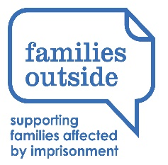

Families Outside - Child Impact Assessment
Toolkit

DATE | VENUE | TIME
Tuesday 24 October 2023 | Online | 10am – 11am

Come along to a one-hour session to learn about the Child Impact Assessment and how you can use this to support and uphold children’s rights when they are impacted by a family members imprisonment.

Learning outcomes
This session will be delivered by Families Outside and will cover:
- The impact of imprisonment on children and young people
- The UNCRC and how rights are impacted by the justice system
- The Child Impact Assessment Toolkit and how to use it

This training is open to anyone who has a role in supporting children and families, within the Tayside area.

To book please use the Eventbrite link below:

24 October 2023 – online Link

