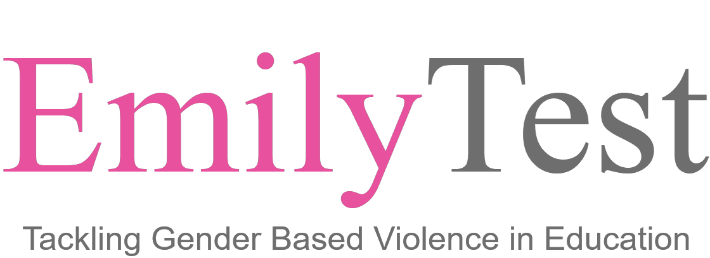
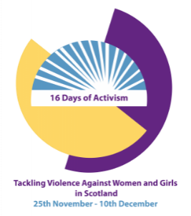
EmilyTest: Gender Based Violence in education - From tragedy to change
Tuesday 28 November 2023 3.45pm – 5.15pm
Via MS Teams

While living in her university halls of residence Emily Drouet was subjected to a relentless campaign of physical and psychological abuse by her university boyfriend. Emily reached out to University staff for help but received a sub-standard response.
During the week that followed, Emily was assaulted several times. Shortly after the last unannounced visit by the abuser, Emily, aged only 18 years old, took her own life. After uncovering a series of preventable failures, Emily's mother Fiona formed EmilyTest with the primary aim of ensuring that no other young person is left to suffer alone and in silence like Emily was.
Closely inspecting policies, procedures and practices, EmilyTest is driving meaningful change by ensuring institutions take their responsibilities to students seriously through developing robust GBV prevention, intervention and support.
In this session, Fiona will share Emily's story and explain how the charity is bringing change out of this painful tragedy.
Trigger warning: This presentation contains strong language, details of domestic abuse, sexual violence and suicide.
Please book a space via Eventbrite;

https://www.eventbrite.co.uk/e/emily-test-tackling-gender-based-violence-in-education-tickets-636517038597

