
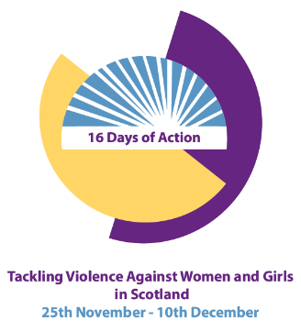

16 Days of Action Against Gender Based Violence 2023
Graham Goulden: Building Moral Rebels to Prevent Male Violence Against Girls and Women
Tuesday 5 December 2023
St. Andrew’s Church, Arbroath
10.30am – 2.30pm (networking tea and coffee from 10am)

Graham Goulden is a former Scottish Police Officer. He spent his last 9 years in policing as a Chief Inspector with the Scottish Violence Reduction Unit. It was in these last years that Graham became a passionate advocate of the Bystander Approach to preventing violence. Now Graham works both nationally and internationally delivering leadership and bystander training in both public and private sector settings, in schools and in universities.
Traditional approaches to preventing men’s violence against girls and women has involved a rigid binary approach which looks at boys and men as perpetrators or potential perpetrators. A focus on bystanders allows those involved in prevention to invite men into conversations rather than simply indict them.
This event that will take place within the 16 days of action against gender-based violence will use the film ‘The Bystander Moment’ which tells the story of one of the most prominent and proven of these prevention models -- the innovative bystander approach developed by pioneering activist and writer Jackson Katz.
Spaces are limited, book early to avoid disappointment
https://www.eventbrite.co.uk/e/16-days-of-action-against-gender-based-violence-2023-tickets-623474668517

