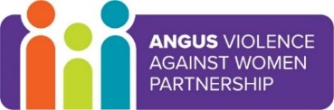
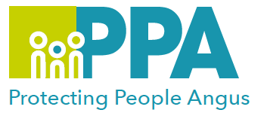
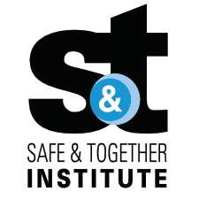

Angus Violence Against Women (AVAWP)
Multi-Agency Learning Events on MS Teams

The Impact of Language in DA and Why it Matters

Wednesday 16 August 2023 1pm – 2pm
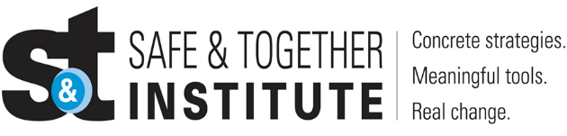

The Safe and Together model provides a framework for working in partnership with the non-offending parent, while holding the perpetrator accountable to achieve better outcomes for families. https://safeandtogetherinstitute.com/

Gender inequality is a root cause of violence against women and girls. Gender-based violence is committed disproportionality by men against women and covers a range of violence and abuse.

Event hosts
Angus Safe and Together Champions.

Learning outcomes
- What is Domestic Abuse
- Understanding of the Safe and Together Model
- Why is language important in our DA practice
- Why we all have a role in changing the culture of DA

Audience
This multi-agency learning session will be ideal for any worker/volunteer, practicing in Angus, who may have contact with survivors of DA. The knowledge in this event will help to support you to support survivors of DA.

To book a place on the training:

https://www.eventbrite.co.uk/e/the-impact-of-language-in-da-and-why-it-matters-tickets-646878349557

