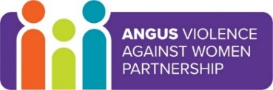
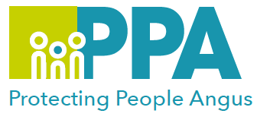
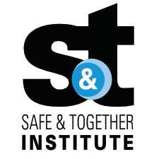

Angus Violence Against Women (AVAWP)
Multi-Agency Learning Events on MS Teams

S&T Focused Report Writing and Assessment

Wednesday 19 July 2023 1pm – 2pm
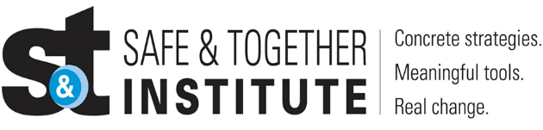

The Safe and Together model provides a framework for working in partnership with the non-offending parent, while holding the perpetrator accountable to achieve better outcomes for families. https://safeandtogetherinstitute.com/

Angus multi-agency, Safe & Together Champions, have developed a series of learning sessions they will deliver once a month to all staff/volunteers in Angus.

Event Hosts
Angus Safe and Together Champions.

Learning Outcomes

- Good practice Safe & Together Principles and Core Components
- Focus on assessment and report writing in relation to Safe & Together
- Consider how to incorporate S&T principles into assessment and report writing, including
  - perpetrator patterns of behaviour, their engagement and willingness to make changes
  - taking a strength-based approach with the survivor
This session will use case studies and report exemplars to support learning.

Audience
This multi-agency learning session will be ideal for any worker/volunteer, practicing in Angus, who may have contact with survivors of DA. The knowledge in this event will help to support you to support survivors of DA.

To book a place on the training:
https://www.eventbrite.co.uk/e/report-writing-and-assessment-tickets-646876042657

Gender inequality is a root cause of violence against women and girls. Gender-based violence is committed disproportionality by men against women and covers a range of violence and abuse.

