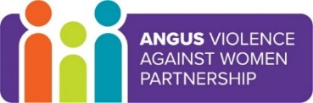
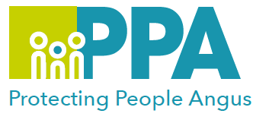
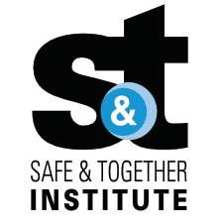

Angus Violence Against Women (AVAWP)

Safe and Together and the Multi-Agency Risk Assessment Conference (MARAC)

Multi-Agency Learning Events on MS Teams

Monday 17 April 2023 1pm – 2pm

The Safe and Together model provides a framework for working in partnership with the non-offending parent, while holding the perpetrator accountable to achieve better outcomes for families. https://safeandtogetherinstitute.com/

Gender inequality is a root cause of violence against women and girls. Gender-based violence is committed disproportionality by men against women and covers a range of violence and abuse.

Event hosts
Angus Safe and Together Champions.

Learning outcomes
- What is Domestic Abuse.
- Understanding of the Safe and Together Model
- Understanding of the Dash risk assessment tool
- What is the MARAC meeting
- Referrals to MARAC
- Who are your MARAC Reps

Audience
This multi-agency learning session will be ideal for any worker/volunteer, practicing in Angus, who may have contact with survivors of DA. The knowledge in this event will help to support you to support survivors of DA.

To book a place on the training

https://www.eventbrite.co.uk/e/safe-and-together-and-the-multi-agency-risk-assessment-conference-marac-tickets-614964795257

